**Model Development Phase Template**

|  |  |
| --- | --- |
| Date | 06-07-2024 |
| Team ID | 739697 |
| Project Title | SmartLender - Applicant Credibility  Prediction for Loan Approval |
| Maximum Marks | 4 Marks |

**Initial Model Training Code, Model Validation and Evaluation Report**

The initial model training code will be showcased in the future through a screenshot. The model validation and evaluation report will include classification reports, accuracy, and confusion matrices for multiple models, presented through respective screenshots.

**Initial Model Training Code:**

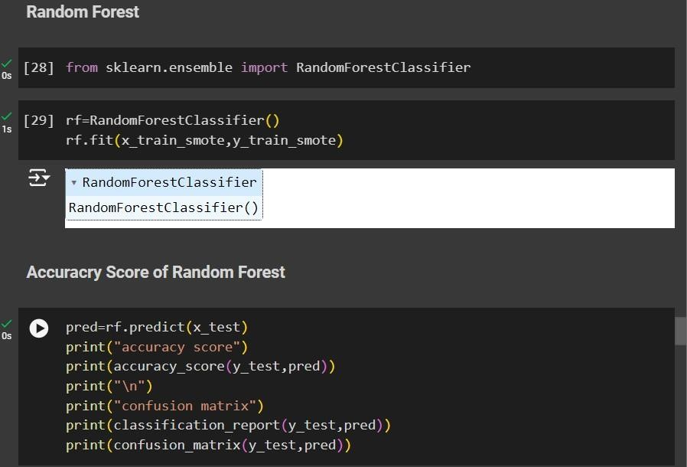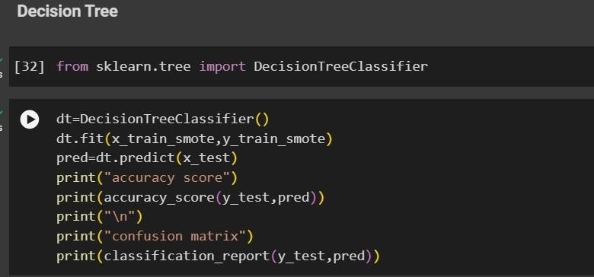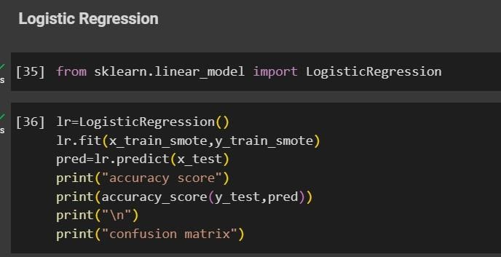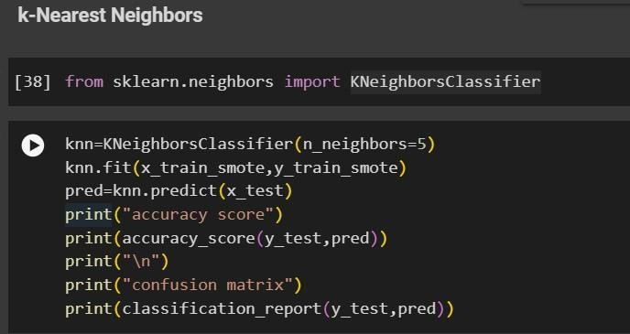

**Model Validation and Evaluation Report:**

|  |  |  |
| --- | --- | --- |
| **Model** | **Classification Report/ Confusion Matrix** | **F1 score** |
| Decision Tree |  | 92% |
| KNN |  | 77% |
| Random  Forest |  | 93% |
| Logistic  Regression |  | 78% |